***Liniments***

By Barbara J. Denny, Certified Herbalist

An herbal liniment is a medicinal preparation that is externally rubbed onto the skin to soothe a variety of ailments. Liniments are regarded as a must-have item for the herbal or natural medicine chest, and can be used in numerous situations. They are best known for their ability to disinfect, warm, dry, heal, soothe and discourage irritation of the skin. Liniments are usually made of tree products. They usually contain camphor, turpentine and wintergreen oils or rubbing alcohol. Always labels your liniments and never ingest as they are poisonous.

Liniments are used for a variety of aches and pains. They include simple backaches, arthritis flair ups and sprains.

The Liniment causes mild irritation when it's rubbed over the affected body part. However, it eventually brings blood to the area, thus soothing it.

Liniments function as relieving sources for minor bodily ailments. They are rather inexpensive and can be bought without a prescription.

Basic Uses of Liniments:

## **Pain Relief**

* Liniment is often used for temporary relief of rheumatic aches and pains; as well as soreness, muscle strains and aches that are due to overexertion.

## **Arthritis**

* Herbal liniment is used to ease uncomfortable symptoms of arthritis. It is sprayed onto the arthritic joint and then thoroughly rubbed in, or a damp gauze containing the liniment is placed over the affected joint.

## **Tendinitis**

* Liniment is also applied to injuries to ligaments, cartilage, tendons and muscles. It can soothe pain, and offer rapid healing. It also helps with herniated disks, overstretched muscles, ankle injuries, knee pain, carpal tunnel syndrome and tennis elbow.

## **Bruises**

* Liniments are extremely rapid ways to treat and eliminate bruises. Liniment should be applied right after a person is bruised. Topical liniment creams are very popular due to their rapid ability to cause bruises to fade.

**Common Liniment**

**Basic Liniment**

1 oz. Echinacea Powder 1 oz. powdered myrrh (an excellent astringent) 1/2 oz. powdered goldenseal (has anti-inflammatory and antibacterial properties) 1/4 oz. cayenne pepper (powerful stimulant and astringent) 1 pint rubbing alcohol

Mix together and let stand seven days. Shake well every day. You can strain the liniment through damp cheesecloth if you don't like the gritty feel of ground herbs. If you leave the herbs in, it gets even stronger. If you don't have goldenseal, make the liniment without it.

**All-Purpose Liniment**Mix together 4 tablespoons of comfrey leaves,   
2 tablespoons each of plantain leaves, yarrow;   
calendula, wormwood leaves, chickweed leaves,   
and 1 ounce of beeswax.

Simmer for several hours. Strain and add 1 teaspoon gum   
benzoin. Cool and test for consistency. Put in   
sterile jar. Label and use on any cut, scrape, or   
rash.

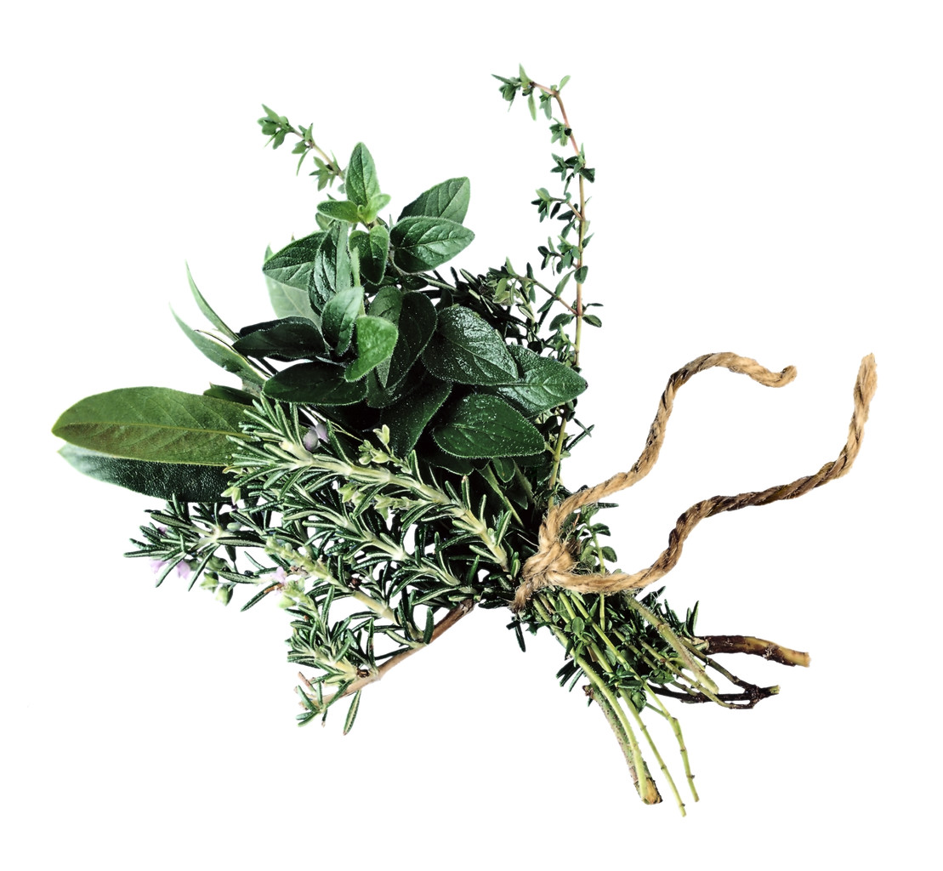

**Arthritis Liniment with Dry Mustard** Rub this liniment in the skin every morning if   
needed. It can be left on the skin until the next   
day.

Mix 1/2 cup each of salt and dry mustard.   
Add enough melted paraffin to make a paste.   
Rub on the affected area. It helps to relieve   
swelling and pain.

**Aching Body Liniment**

Add 4 tablespoons of powdered goldenseal to 4   
cups of rubbing alcohol.

Let sit for 2 weeks,   
shaking daily. Use as a massage for aching   
muscles.

**Liniment for Stiffness**Add 1 tablespoon each of cayenne pepper,   
wormwood, and tansy flowers to 1 cup of cider   
vinegar. Warm gently for 1 hour.

Cool, strain, and add 1 tablespoon spirits of camphor and 1   
cup of rectified turpentine to the herbal vinegar.   
After rubbing the affected area with the   
liniment, cover with a flannel cloth to keep   
warm. This is good for just about any stiffness,   
arthritis, rheumatism, or sore muscles.

**Skin Liniment with Calendula**Use this for a multitude of skin disorders. Mix   
2 cups of olive or vegetable oil with 2 cups of   
calendula petals and leaves.

C:\Documents and Settings\Barbaras\Local Settings\Temporary Internet Files\Content.IE5\0JAXMH8Z\MC900312546[1].wmf

Place pan in an oven at low heat (about 150 degrees) and   
heat for several hours. Strain well and add 1/4   
teaspoon of tincture of benzoin. Pour into a   
sterile bottle. Rub onto skin.

**Sore Muscles Liniment**Mix together 1/4 cup each of olive oil and   
spirits of camphor. Use to massage sore   
muscles.

**Sprain Liniment**Bruise a couple of handfuls of sage leaves.   
Use dried sage if fresh is not available. Put the   
sage in 1 cup of vinegar and boil for 5   
minutes.

Dip a cloth in the boiling-hot vinegar   
and herb mixture and wring it out. Apply it to   
the sprain. Make sure the cloth is as hot as   
you can stand it.