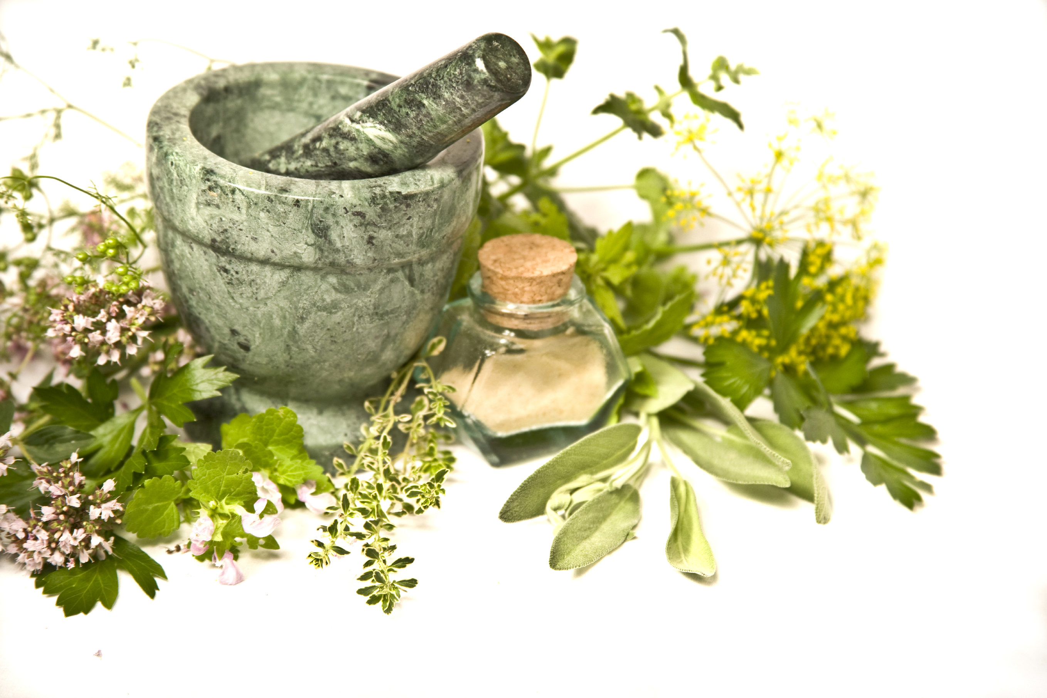

THE HEALING GARDEN
By: Barbara J. Denny, Certified Herbalist, www.serenityacresfarm.net

Restocking your medicine cabinet can be as easy as going into your garden. There are safe, effective, dependable, time tested herbs that will cure many afflictions. Used carefully they offer an alternative to more expensive, synthetic medications. These herbal helpers rarely have adverse side effects that many pharmaceuticals have.
As a Certified Herbalist, I am trained to prepare many salves, tinctures, infusions, poultices and capsules that have helped relieve ailments in both two and four legged creatures. Many herbs can be used as remedies direct from the garden with out much preparation. Here are a few I use frequently that are easy to grow:
- Aloe Vera is a succulent plant that will grow best indoors in our climate. It is used for minor burns. Studies have shown that Aloe stimulates the creation of new skin cells. Having an anti-inflammatory action it aids in reducing swelling of wounds, while it’s anti-microbial and immune stimulating aspects helps prevent infection. I keep a small potted plant in my kitchen. When needed, I snip off one of the leathery leaves, slit it open, and apply the gel inside onto the wound. The rest of the leaf can be stored in the refrigerator in a plastic bag for reapplication, discarding after a few days. Of course, if you have a major burn or wound professional medical attention is advised.
- Lavender (Lavandula angustifolia) has been used since ancient times as a tranquilizer, sleep aid, and digestive aid. A tea using one to three teaspoons of lavender flowers per cup of boiling water will settle an upset stomach as well as help you sleep better when drank before bed. For a relaxing bath, place a handful of flowers in a washcloth and tie to close, then add to the bath while running the water. A strong tea or oil can be added to the bath instead. Another wonderful way to induce sleep is by making a lavender pillow. Take two six inch squares of fabric and sew together, adding a handful of lavender to the stuffing. Place the pillow under your pillow and drift off to blissful sleep.
- Roman Chamomile is extremely easy to grow in our area, and will reseed itself for years of harvests. It is important to obtain Roman and not German Chamomile as it has stronger medicinal value. Harvest the flowers just after they have opened wide. They resemble tiny daisies. This herb has a long history as a tranquilizer and is supported by recent research. A compound in its oil called apigenin has been found by Argentinean researchers to bind to the same cell receptors as the Valium family of pharmaceutical tranquilizers. Japanese researchers exposed animals to Chamomile vapors while they were under stress and their hormone levels fell significantly. I keep a jar of flowers both in my kitchen and at my office and enjoy a cup of relaxing tea frequently. It has a delightful taste that needs no honey or sweeteners. It will also sooth an upset stomach.
- Peppermint (Mentha x piperita) is rich in menthol and carvone, both of which sooth the digestive tract. It helps treat colds and its mild anesthetic helps sooth a sore throat when taken in tea form. Inhaling Peppermint tea vapors helps relieve nasal congestion as well. For indigestion or colds, make a tea using one to two teaspoons of dried herb per cup of boiling water.
Always be wary of herb/drug interactions. If you are on prescribed medications ask your doctor before adding herbal preparations to your diet. If you are over 65, begin with lower doses as age increases sensitivity. Watch for allergic reactions or adverse effects such as upset stomach, diarrhea, headache or rash. Discontinue use and wait a period before trying a lower dose. Reactions are rare, but as with anything we ingest, there is always the possibility.
As the summer heats up add ice to Peppermint or Chamomile tea and enjoy a refreshing twist to your traditional beverage.

